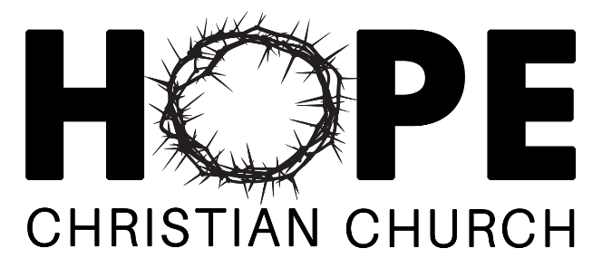 2021 FALL APPAREL
Dri-Mesh® Polo $35 S M L XL 2XL 3Xl $ __________________
(light blue)
1/4-Zip Pullover $35 S M L XL 2XL 3Xl $ __________________
(black heather)

Crewneck Sweatshirt $40 S M L XL 2XL 3Xl $ __________________
(seafoam)

Full Zip Hoodie $45 S M L XL 2XL 3Xl $ __________________
(navy)
Hooded Sweatshirt $48 S M L XL 2XL 3Xl $ __________________
Adult (grey)
Hooded Sweatshirt $25 S M L XL $ __________________
Youth (light grey)

Knit Hat $12 $ __________________
(orange, grey, blue)
Trucker Hat $12 $ __________________
TOTAL DUE $ __________________

